Assignment One: Requirements Checking Report
Daniëlle Jongstra, Joanna Kisaakye

Table of Contents
Assignment One: Requirements Checking Report 3
Class Diagram 3
Sequence Diagrams 4
Use Case 3 4
Use Case 7 5
Regular Expressions and Finite State Automata 6
Use Case 3 6
Use Case 7 6
Implementation Bug Fix 6
References 7
Footnotes 8
Tables 9
Figures 10

Assignment One: Requirements Checking Report

Class Diagram
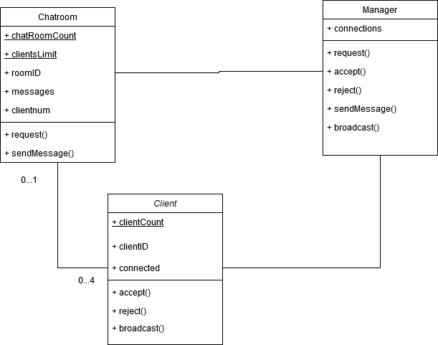
Figure 1:Class Diagram
For the class diagram (Figure 1), the implementation given in chatProtocolSimulation.py is followed as much as possible. The class, or static, attributes in the Chatroom and Client classes are underlined. The other attributes are initialized for each instance of the classes and are therefore not underlined. All the attributes and methods are considered public in this class diagram. It is not possible to declare either the attributes or the methods private in python, but it is seen as a safe assumption since the convention is to use an underscore as the first character in the name for a method or attribute that would in other programming languages be declared private.

The cardinalities in the diagram are assigned between the classes of Chatroom and Client. For each Client there is 0 or 1 Chatroom, as a client can either be in one chat room or in no chat room when he/she still has to connect to one. The textual description on the assignment web page specifies that a chat room can accept at most four clients. The cardinality constraint 0...4 in the diagram specifies this.

The relationship between Manager and Client is a normal association. It is clearly not a realization or generalization. The relationship is also not a dependency, as neither of the classes are an attribute of the other class. If we do not look too closely at the implementation, it could be an has-a relationship. The Manager has (a list of) client(s) in that case. Considering that the relationship between Chatroom and Manager is similar to the relationship of Manager and Client, the same thought process is followed for this relationship. Now, we should also keep in mind that the class Chatroom also calls methods of the class Manager. In a has-a relationship the Manager would know about the Chatroom, but not the other way around. Because the similarity of the relationships, neither of the relationships with the Manager class are specified as a has-a relationship.

Sequence Diagrams

Use Case 3
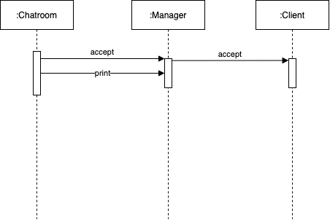
Figure 2: Use Case 3 Sequence Diagram
According to the implementation in chatProtocolSimulation.py, a chat room accepts a client within its request method by calling the accept method of the Manager. The Manager then calls the accept method of the client which is responsible for changing the clients state to reflect that it is now connected to a chatroom. The Manager also updates its state, within its own accept method, by appending the client, room pair to its map of connections.
Since none of the accept methods of the Client or Manager return anything to the caller, the Chatroom proceeds to dump to the output by printing the Manager.

Use Case 7
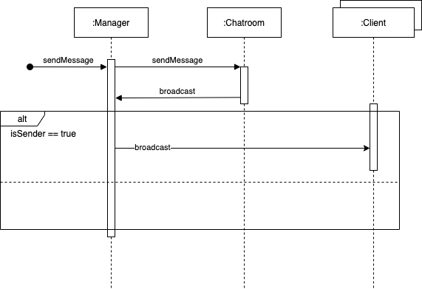
Figure 3: Use Case 7 Sequence Diagram
According to the implementation in chatProtocolSimulation.py, when a Manager receives a call to its sendMessage method, it in turn calls the sendMessage method of the chatroom. That sendMessage method calls the broadcast method of the Manager.
Within the Manager, the broadcast method calls the broadcast method of all connected clients. This diverts from the use case because there is supposed to be a check to ensure that the client that sent the message does not receive the message, as shown in the sequence diagram in Figure 3 above.

Regular Expressions and Finite State Automata

Use Case 3
Figure 4: Use Case 3 Finite State Automata

Use Case 7
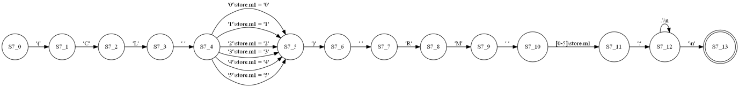
Figure 5: Use Case 7 Finite State Automata

Implementation Bug Fix
To fix the implementation bug present in chatProtocolSimulation.py, we add an extra line to the broadcast method of the manager that checks that the client Id of the client receiving the message is not the same as the sender Id.
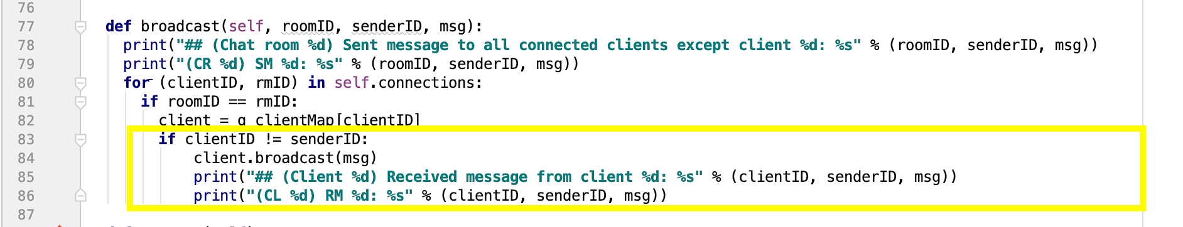
Figure 6: Fixed code in chatProtocolSimulationFixed.py
That is all that is required to fix the implementation bug.

References
Surname, F. M. (Year). Article Title. Journal Title, Pages From-To.
Surname, F. M. (Year). Book Title. City Name: Publisher Name.

Footnotes
1[Add footnotes, if any, on their own page following the references. For APA formatting requirements, it’s easy to just type your own footnote references and notes. To format a footnote reference, select the number, then apply the Footnote Reference. The body of a footnote, such as this example, uses the Normal text style. (Note: If you delete this sample footnote, don’t forget to delete its in-text reference as well.)]

Tables
Table 1
[Table Title]
Column Head | Column Head | Column Head | Column Head | Column Head
Row Head | 123 | 123 | 123 | 123
Row Head | 456 | 456 | 456 | 456
Row Head | 789 | 789 | 789 | 789
Row Head | 123 | 123 | 123 | 123
Row Head | 456 | 456 | 456 | 456
Row Head | 789 | 789 | 789 | 789
Note: [Place all tables for your paper in a tables section, following the references (and, if applicable, the footnotes). Start a new page for each table, include a table number and table title for each, as shown on this page. All explanatory text appears in a table note that follows the table, such as this one. Use the Table/Figure style to get the spacing between table and note. Tables in APA format can use single or 1.5-line spacing. Include a heading for every row and column, even if the content seems obvious. To insert a table, on the Insert tab, tap Table. New tables that you create in this document use APA format by default.]

Figures

Figure 1. [Include all figures in their own section, following references (and footnotes and tables, if applicable). Include a numbered caption for each figure. Use the Table/Figure style for easy spacing between figure and caption.]
For more information about all elements of APA formatting, please consult the APA Style Manual, 6th Edition.

